**Exercise 1: Control Structures**

**Scenario 1:** The bank wants to apply a discount to loan interest rates for customers above 60 years old.

* + **Question:** Write a PL/SQL block that loops through all customers, checks their age, and if they are above 60, apply a 1% discount to their current loan interest rates.

**PL/SQL CODE:**  
  
SET SERVEROUTPUT ON;

BEGIN

FOR cust IN (

SELECT CustomerID

FROM Customers

WHERE MONTHS_BETWEEN(SYSDATE, DOB)/12 > 60

) LOOP

UPDATE Loans

SET InterestRate = InterestRate - 1

WHERE CustomerID = cust.CustomerID;

DBMS_OUTPUT.PUT_LINE('Applied discount to Customer ID: ' || cust.CustomerID);

END LOOP;

END;

/  
  
**OUTPUT:** 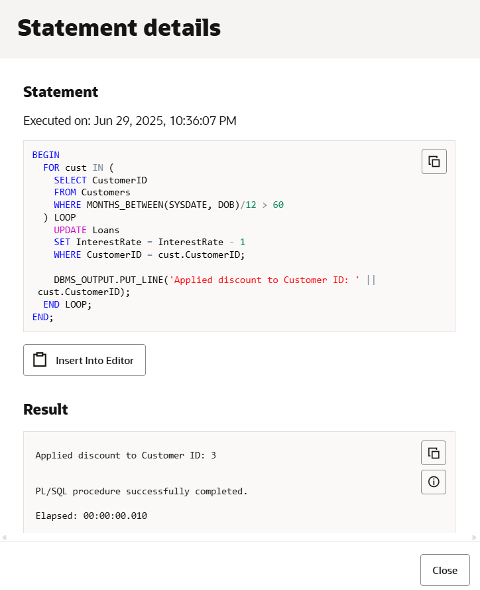

**Scenario 2:** A customer can be promoted to VIP status based on their balance.

* + **Question:** Write a PL/SQL block that iterates through all customers and sets a flag IsVIP to TRUE for those with a balance over $10,000.

**PL/SQL CODE:**

BEGIN

FOR cust IN (

SELECT CustomerID

FROM Customers

WHERE Balance > 10000

) LOOP

UPDATE Customers

SET IsVIP = 'TRUE'

WHERE CustomerID = cust.CustomerID;

DBMS_OUTPUT.PUT_LINE('Marked Customer ID ' || cust.CustomerID || ' as VIP');

END LOOP;

END;

/  
**OUTPUT:**

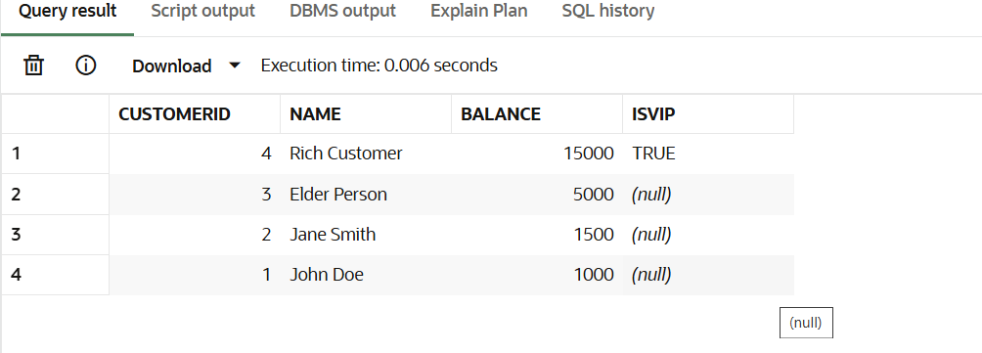

**Scenario 3:** The bank wants to send reminders to customers whose loans are due within the next 30 days.

* + **Question:** Write a PL/SQL block that fetches all loans due in the next 30 days and prints a reminder message for each customer.

**PL/SQL CODE:**

BEGIN

FOR loan IN (

SELECT l.LoanID, c.Name, l.EndDate

FROM Loans l

JOIN Customers c ON l.CustomerID = c.CustomerID

WHERE l.EndDate <= SYSDATE + 30

) LOOP

DBMS_OUTPUT.PUT_LINE('Reminder: Loan ID ' || loan.LoanID || ' for ' || loan.Name || ' is due on ' || TO_CHAR(loan.EndDate, 'DD-MON-YYYY'));

END LOOP;

END;

**/  
OUTPUT**